**PROJECT**

1. Write a mapreduce program to remove commas present inside the double quotes.

COMMAND: 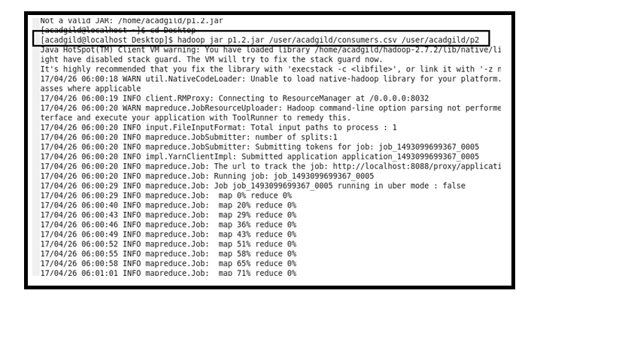

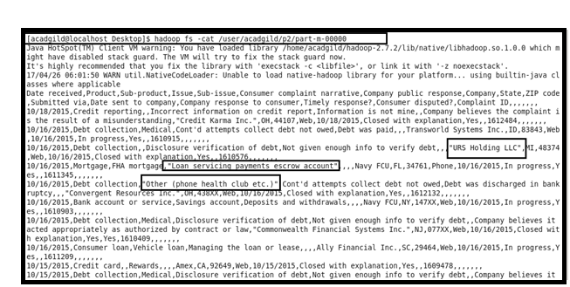

NOW WE ARE USING GET COMMAND TO COPY TO LOCAL FOR DOING PIG :

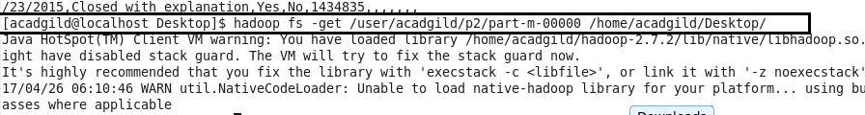

**PIG PROGRAM :**

1. Write a pig script to find no of complaints which got timely response.

COMMAND :

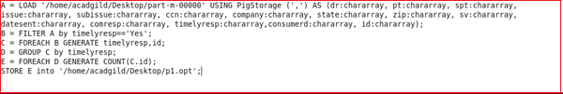

OUTPUT :

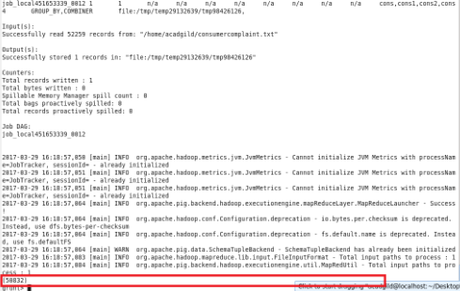

1. Write a pig script to find no of complaints where consumer forum forwarded the complaint same day they received to respective company.

COMMAND :

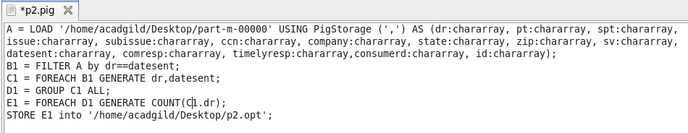

OUTPUT :

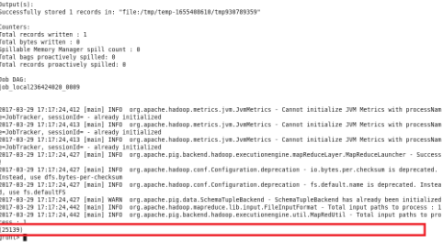

1. Write a pig script to find list of companies topping in complaint chart (companies with maximum number of complaints).

COMMAND:

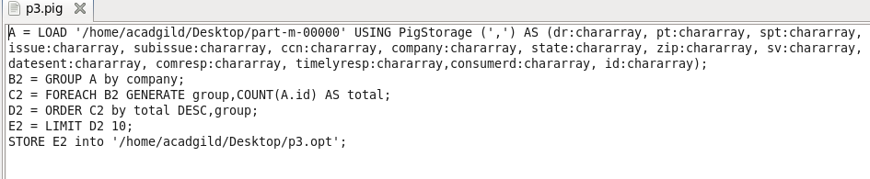

OUTPUT:

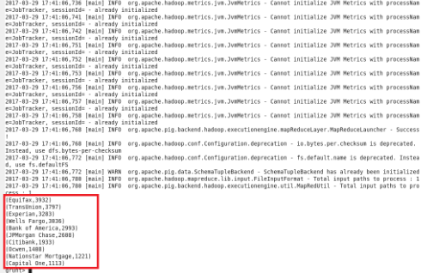

1. Write a pig script to find no of complaints filed with product type has “Debt collection” for the year 2015.

COMMAND :

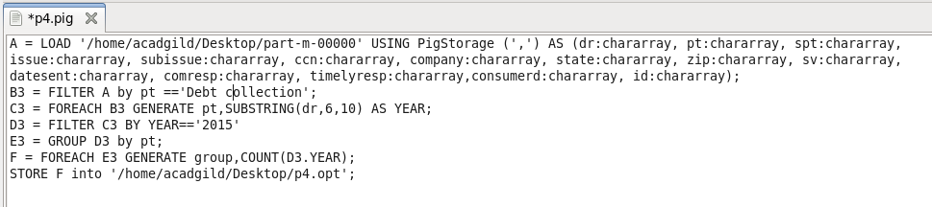

OUTPUT :

